SOP On Impact SFTP Server certificate renewal

Preface :-
The document helps to renew the certificate on the sftp servers.
HLD :-
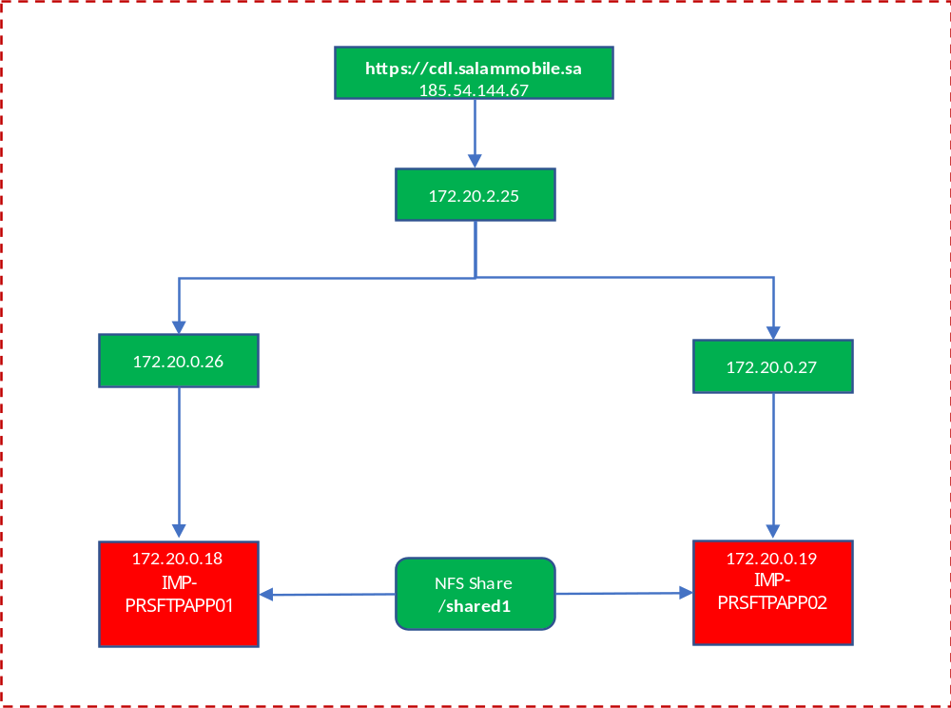

Servers details are part of the above HLD.
IMP-PRSFTPAPP01.itc.local  IMP-PRSFTPAPP02.itc.local | 172.20.2.97  172.20.2.98

Current certificate artifacts :-

